Web Development (Introduction)
WEDE5020
Arivhanzhi Phaswana
ST10523912
PROPOSALS.

Proposal for EcoClean Solar Solutions Website
- Organisation Overview
Name: EcoClean Solar Solutions
EcoClean Solar Solutions is a South African company that cleans and maintains solar panels for homes, businesses, and farms. Dirty panels lose efficiency and cost owners money. EcoClean uses deionized water and soft brushes to clean panels safely without voiding warranties. The company was founded to help solar owners protect their investment.
Mission: To help solar owners get the most from their investment through safe, chemical-free cleaning and maintenance.
Vision: To become South Africa's most trusted solar maintenance provider.
Target audience: Homeowners with rooftop solar, commercial property managers, and agricultural businesses.
- Website Goals and Objectives
Goals:
- Generate quote requests from potential customers.
- Educate visitors about why professional cleaning matters.
- Showcase services and pricing clearly.
Objectives and KPIs:
- Get 20 quote requests per month (form submissions).
- Achieve 500 visitors per month (Google Analytics).
- Keep bounce rate below 50%.
- Have visitors spend at least 2 minutes on site.
- Current Website Analysis
EcoClean has no website yet. This means no online presence, no way for customers to request quotes, and no platform to explain services. Competitors often have outdated sites that don't work well on phones. We can stand out by building a fast, mobile-friendly site with clear pricing and easy quote forms.
- Proposed Website Features and Functionality
The website will have five pages:
- Home: Hero image, why cleaning matters, three key benefits.
- About Us: Mission, technology, safety standards.
- Services & Pricing: Three service types, comparison table, FAQs.
- Solar Care Hub: Three educational guides (water damage, hotspots, bird proofing).
- Request Quote: Contact info, quote request form, map.
Functionality:
- Responsive design for phone, tablet, desktop.
- Quote form with validation.
- Embedded Google Map.
- Clear calls to action.
- Design and User Experience
Colour scheme: Teal (#0e8388) for trust, gold (#f2a900) for energy, dark grey (#1b262c) for text, light grey (#f4f7f4) for backgrounds.
Typography: Open Sans for body and headings. Clean and readable.
Layout: Clean, spacious, with cards and sections. Mobile-first.
Wireframes: Low-fidelity wireframes.
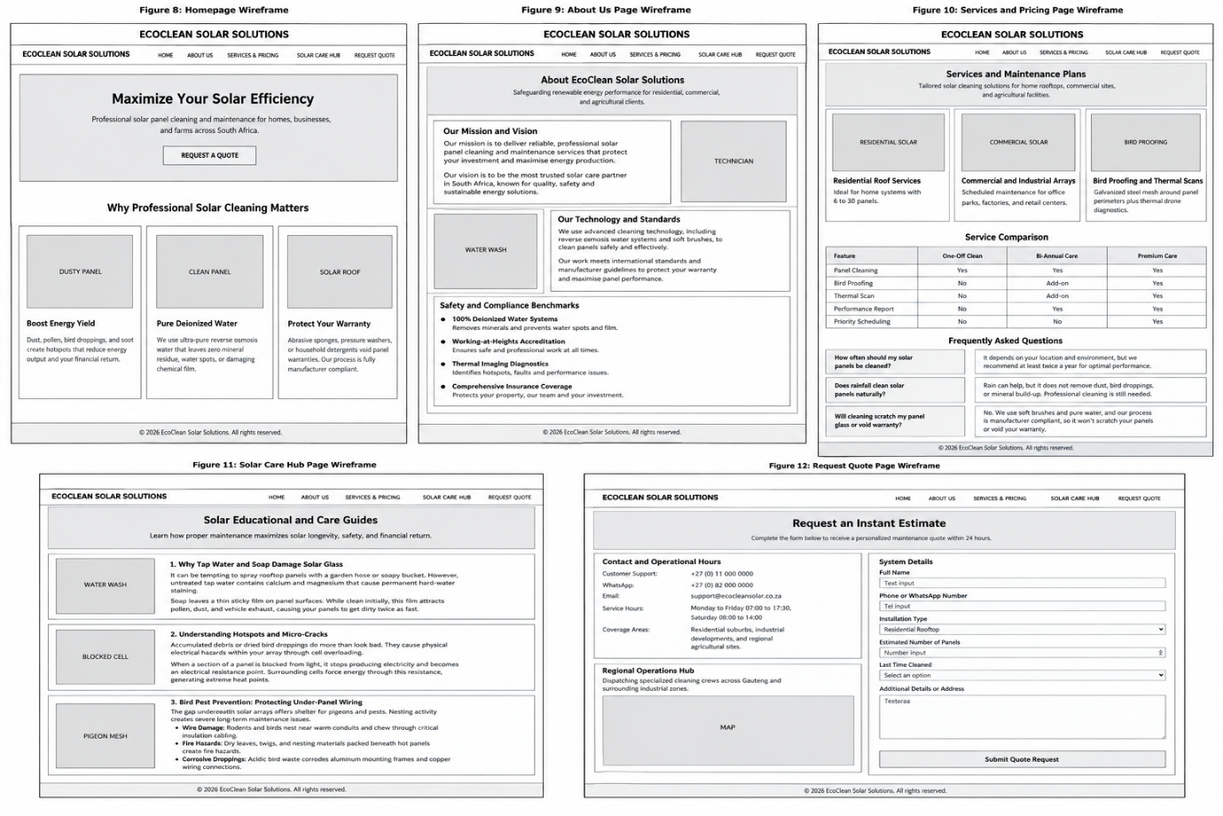
- Technical Requirements
Hosting: Netlify or GitHub Pages (free).
Domain: ecocleansolar.co.za (approx R250/year).
Languages: HTML5, CSS3, JavaScript.
Tools: Visual Studio Code, Git, GitHub.
- Timeline and Milestones
Part 1 (HTML): Weeks 1-4.
Part 2 (CSS): Weeks 5-8.
Part 3 (JS & SEO): Weeks 9-12.
Key milestones: Proposal approval (Week 2), HTML complete (Week 4), CSS complete (Week 6), final deployment (Week 12).
- Budget
Domain: R250 per year.
Hosting: R0 (free tier).
Images: R0 (free stock).
Tools: R0 (free).
Total: R250 per year.
- References
W3Schools. (2026). HTML Tutorial. Available at: https://www.w3schools.com/html/ (Accessed: 18 September 2026).
Mozilla Developer Network. (2026). HTML: HyperText Markup Language. Available at: https://developer.mozilla.org/en-US/docs/Web/HTML (Accessed: 18 September 2026).
Google Fonts. (2026). Open Sans. Available at: https://fonts.google.com/specimen/Open+Sans (Accessed: 18 September 2026).

Proposal for Deras Traditional Medicine Website
- Organisation Overview
Name: Deras Traditional Medicine
Deras Traditional Medicine is a South African practice that offers natural, plant-based remedies for common health issues. The founder, Dr. Deras, has over 15 years of experience in traditional healing. The practice focuses on treating colds, flu, skin conditions, digestion problems, and stress-related ailments. All remedies are made from locally sourced herbs and are prepared using traditional methods.
Mission: To provide safe, affordable, and effective traditional medicine to people who prefer natural healing.
Vision: To become South Africa's most trusted traditional medicine practice, bridging the gap between ancient knowledge and modern wellness.
Target audience: Adults looking for natural alternatives to conventional medicine, health-conscious individuals, and people in rural and urban areas who trust traditional healing.
- Website Goals and Objectives
Goals:
- Allow patients to book consultations online.
- Educate visitors about the benefits of traditional medicine.
- Sell herbal remedies directly through the website.
Objectives and KPIs:
- Get 30 consultation bookings per month (form submissions).
- Achieve 800 visitors per month (Google Analytics).
- Sell 50 products per month (e-commerce tracking).
- Keep bounce rate below 45%.
- Current Website Analysis
Deras Traditional Medicine has no website. This means no online booking, no product sales, and no way for new patients to learn about the practice. Many potential customers search online for natural remedies but cannot find this practice. Building a website will open a new channel for bookings and sales.
- Proposed Website Features and Functionality
The website will have five pages:
- Home: Hero image, welcome message, featured remedies, why choose us.
- About Us: Dr. Deras's story, qualifications, philosophy.
- Remedies: Product listings with descriptions, prices, and a comparison table.
- Health Hub: Articles on natural healing, herbal guides, and FAQs.
- Contact & Booking: Contact details, booking form, map, operating hours.
Functionality:
- Responsive design for all devices.
- Booking form with validation.
- Product gallery with lightbox (Part 3).
- Search functionality for remedies (Part 3).
- Design and User Experience
Colour scheme: Earthy green (#2e7d32) for nature, warm brown (#795548) for tradition, cream (#f5f5dc) for backgrounds, dark grey (#212121) for text.
Typography: Lora for headings (traditional feel), Open Sans for body (readable).
Layout: Clean, organic, with soft edges and natural imagery. Mobile-first.
Wireframes: Low-fidelity wireframes for each page are included below.
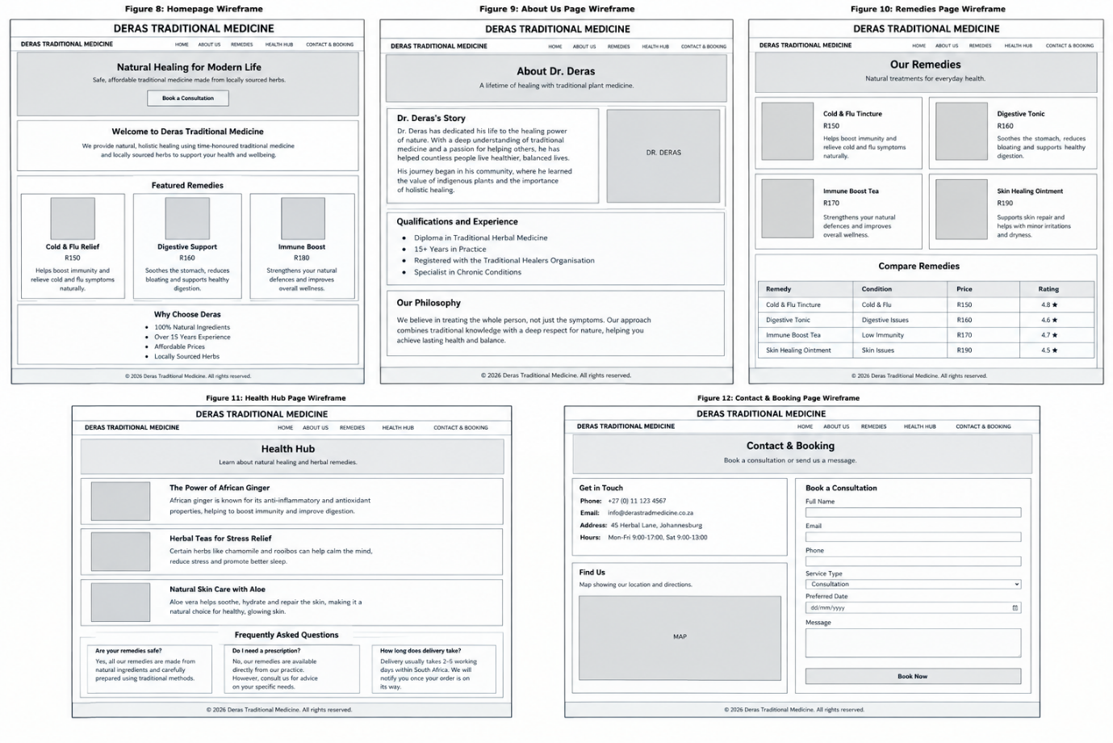
- Technical Requirements
Hosting: Netlify or GitHub Pages (free).
Domain: derastradmedicine.co.za (approx R250/year).
Languages: HTML5, CSS3, JavaScript.
Tools: Visual Studio Code, Git, GitHub.
- Timeline and Milestones
Part 1 (HTML): Weeks 1-4.
Part 2 (CSS): Weeks 5-8.
Part 3 (JS & SEO): Weeks 9-12.
Key milestones: Proposal approval (Week 2), HTML complete (Week 4), CSS complete (Week 6), final deployment (Week 12).
- Budget
Domain: R250 per year.
Hosting: R0 (free tier).
Images: R0 (free stock).
Tools: R0 (free).
Total: R250 per year.
- References
W3Schools. (2026). HTML Tutorial. Available at: https://www.w3schools.com/html/ (Accessed: 18 September 2026).
Mozilla Developer Network. (2026). HTML: HyperText Markup Language. Available at: https://developer.mozilla.org/en-US/docs/Web/HTML (Accessed: 18 September 2026).
Google Fonts. (2026). Lora and Open Sans. Available at: https://fonts.google.com/ (Accessed: 18 September 2026).

